Guided Exploration 04: Django

Django
Portfolio Views
  - Portfolio detail pages and testing

ISA SAMIZADE-YAZD
MSU DENVER
CS1030-003 | FALL 2026
isamieza@msudenver.edu
Owner | CEO of VEN1M, LLC
ven1m.com

Contents
1. From URL to portfolio Page 2
2. Working application Page 3
3. Tests and results Page 4
Reviewed November 12, 2026

1. From URL to portfolio
The project displays student portfolios and their related projects from a local SQLite database. GE04 replaces the function-based portfolio detail handler with Django’s generic DetailView. The updated page displays the title, about text, contact email, active status and complete project descriptions.

Retrieving the selected record
URL route in django_project/urls.py
path("portfolios/<int:pk>/",
views.PortfolioDetailView.as_view(), name="portfolio-detail")
For /portfolios/1/, the URL converter passes the integer 1 as pk. as_view() connects the class to Django’s request handling. DetailView uses pk to retrieve one Portfolio from the view’s queryset. If no matching object exists, the response is HTTP 404.
PortfolioDetailView in portfolio_app/views.py
class PortfolioDetailView(DetailView):
model = Portfolio
template_name = "portfolio_app/portfolio_detail.html"
context_object_name = "portfolio"
get_queryset() limits the results to active portfolios. select_related("student") loads the student with the portfolio. prefetch_related("projects") loads the related projects so the template can display them without a separate query for each item. The template receives the selected record under the name portfolio.

Relationships and navigation
Portfolio.student is a OneToOneField: one student can have at most one portfolio. Project.portfolio is a ForeignKey with related_name="projects": one portfolio can have many projects. The template iterates over portfolio.projects.all, so it displays only projects linked to the selected portfolio. Its empty branch displays “No projects have been added yet.”
On the home page, Portfolio.get_absolute_url() builds a link from the portfolio-detail URL name and the record’s primary key. The detail page uses the portfolio-list URL name for its Back to all portfolios link. These names avoid hard-coding the destination paths in the template.

2. Working application
These November 4 screenshots show the local application and its example records. The empty portfolio was added through the ORM for the existing John Smith record.
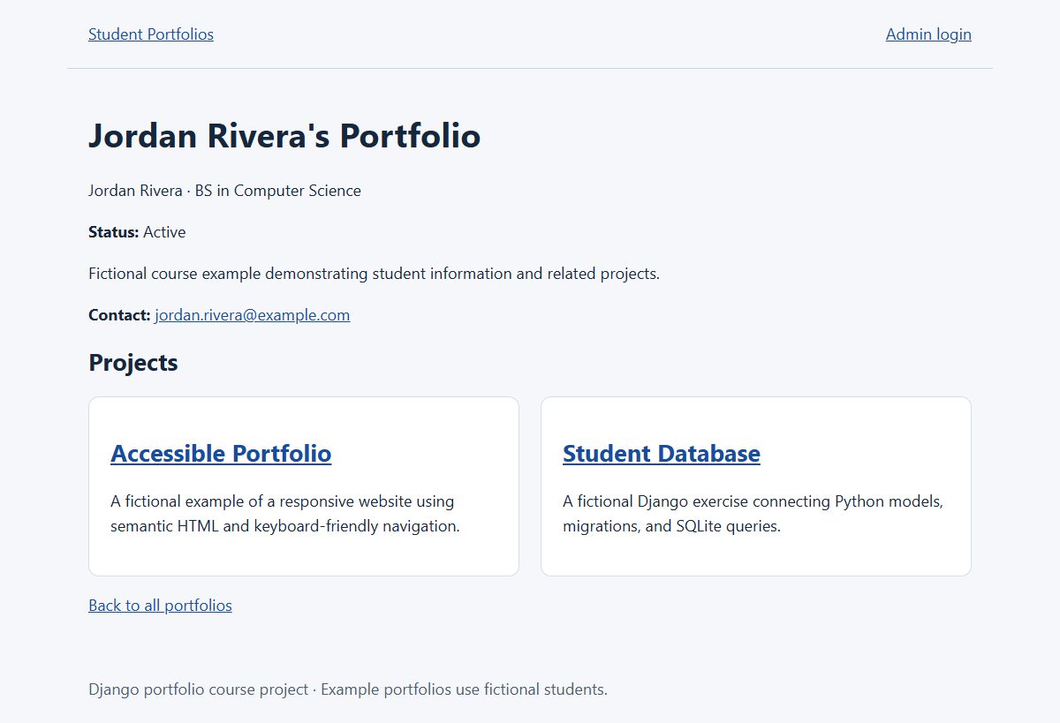
Figure 1. /portfolios/1/: Jordan Rivera’s portfolio displays its two projects, status and contact email.
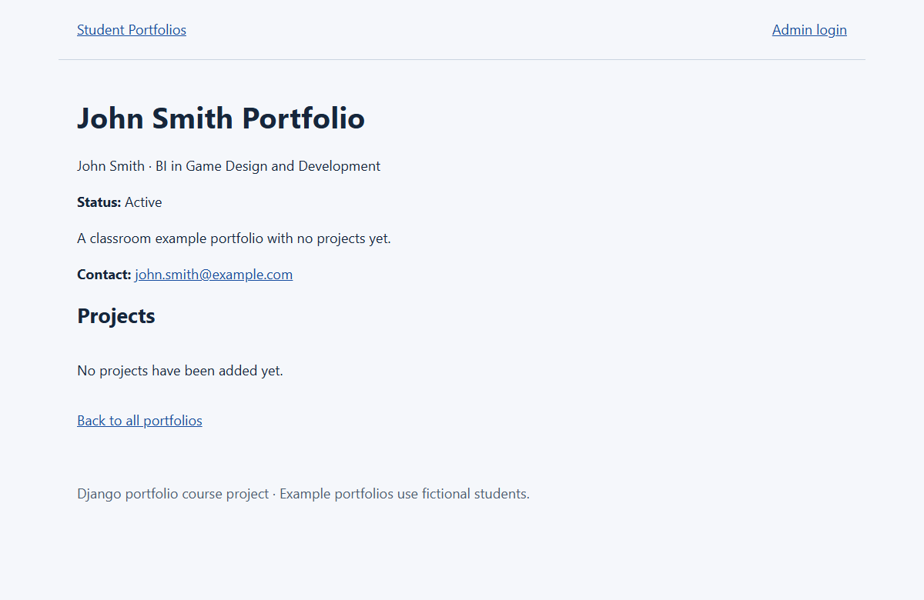
Figure 2. /portfolios/3/: John Smith’s portfolio displays the empty-project message and return link.

3. Tests and results
On November 12, the Django suite passed all 32 tests: the original 12 tests plus 20 student and portfolio workflow tests. The five GE04 checks still pass. Tests use an isolated database. The system check reported no issues, and the migration check found no changes.
Check | Expected result | Recorded result
Different portfolio IDs | Each ID selects the correct title, about, email and status. | Pass: all field assertions matched.
Project relationships | Only related projects appear, with full descriptions. | Pass: unrelated projects excluded; long description retained.
Empty portfolio | Display a helpful message without unrelated projects. | Pass: message present; browser response 200.
Missing ID | Return HTTP 404. | Pass: test passed; /portfolios/999999/ returned 404 in the browser.
Navigation | Open a portfolio from home and return home. | Pass: link assertions and browser click sequence succeeded.

Automated browser checks also returned HTTP 200 for home and portfolio IDs 1, 2 and 3. The detail page had no horizontal overflow at a 390-pixel viewport.

Running the tests
Run these commands from the project folder
.\djvenv\Scripts\python.exe manage.py check
.\djvenv\Scripts\python.exe manage.py test -v 2
.\djvenv\Scripts\python.exe manage.py makemigrations --check --dry-run

Project scope
No schema changes were required for GE04. Individual Project pages remain available, and inactive portfolios remain private. The subsequent L22 forms are documented separately in the Django workflow technical document.

Repository and test files
Repository: https://github.com/VEN1M-DC/django-portfolio
Current branch: codex/l22-student-portfolio
GE04 tests: portfolio_app/tests.py
Screenshots and browser checks recorded November 4.

